HQ AFSVA/SVPAR
Annual Instrument

REEXAMINATION

1 August 2002
(Incorporates change 1, dated 17 Dec 02)

(Required passing score: 80%)

Please do not mark on booklet
Annual Instrument Reexamination Questions (50)

(Chg 1, 17 Dec 02)(Question 1 references FAA-H-8083-15 (IFH-new))

1. (Refer to figures 22 and 24.) For planning purposes, what would be the highest MEA on V187 between Grand Junction, Walker Airport and Durango, La Plata Co. Airport?

A. 12,000 feet
B. 16,000 feet
C. 15,000 feet

(Chg 1, 17 Dec 02)(Question 2 references AC 61-23 (PHAK))

2. Determine the time to be entered in block 10 of the flight plan. (Refer to the FD excerpt below, and use the wind entry closest to the flight planned altitude.)
Route of flight Figures 69, 70, and 71
Flight log and MAG VAR Figure 70
JUDDS TWO ARRIVAL
and Excerpt from AFD Figure 72

FT 3000 6000 9000
BDL 3320 3425+05 3430+00

A. 58 minutes
B. 1 hour 14 minutes
C. 50 minutes

(Chg 1, 17 Dec 02)(Question 3 references AC 61-27C (IFH-old))

3. During normal coordinated turns, what error due to precession should you observe when rolling out to straight and level flight from a 180° steep turn to the right?
A. A straight and level coordinated flight indication
B. The miniature aircraft would show a slight turn indication to the left
C. The miniature aircraft would show a slight descent and wings level attitude

(Chg 1, 17 Dec 02)(Questions 4 - 5 reference FAA-H-8083-15)

4. Which is the correct sequence for recovery from a spiraling, nose low, increasing airspeed, unusual flight attitude?
A. Reduce power, raise the nose to level attitude, and correct the bank attitude
B. Reduce power, correct the bank attitude, and raise the nose to a level attitude
C. Increase pitch attitude, reduce power, and level wings

5. When making an instrument approach at the selected alternate airport, what landing minimums apply?
- The landing minimums published for the type of procedure selected
- Standard alternate minimums (600-2 or 800 2)
- The IFR alternate minimums listed for that airport

(Chg 1, 17 Dec 02)(Question 6 references AC 61-27C)

6. If, while in level flight, it becomes necessary to use an alternate source of static pressure vented inside the airplane, which of the following should the pilot expect?

A. The vertical speed to momentarily show a climb
B. The altimeter to read lower than normal
C. The vertical speed to momentarily show a descent

(Chg 1, 17 Dec 02)(Questions 7 - 10 reference FAA-H-8083-15)

7. When holding at an NDB, at what point should the timing begin for the second leg outbound?

A. When abeam the holding fix
B. When the wings are level and the wind drift correction angle is established after completing the turn to the outbound heading
C. When the wings are level after completing the turn to the outbound heading, or abeam the fix, whichever occurs first

8. What should be the indication on the magnetic compass as you roll into a standard rate turn to the left from a west heading in the Northern Hemisphere?

A. The compass will indicate the approximate correct magnetic heading if the roll into the turn is smooth
B. The compass will initially indicate a turn to the right
C. The compass will remain on west for a short time, then gradually catch up to the magnetic heading of the aircraft

9. (Refer to figure 89.) What VHF frequencies are available for communications with Cedar City FSS?

A. 122.2, 121.5, 122.0, and 123.6
B. 123.6, 121.5, 108.6, and 112.8
C. 122.2, 121.5, 122.6, and 112.1

10. (Refer to figure 73.) What is the minimum altitude at which you should intercept the glide slope on the ILS RWY 6 approach procedure?

A. 1,690 feet MSL
B. 1,800 feet MSL
C. 3,000 feet MSL

(Questions 11 - 27 reference AIM)

11. When ATC has not imposed any climb or descent restrictions and aircraft are within 1,000 feet of assigned altitude, pilots should attempt to both climb and descend at a rate of between

A. 500 feet per minute and 1,000 feet per minute
B. 1000 feet per minute and 2,000 feet per minute
C. 500 feet per minute and 1,500 feet per minute

12. What effect would a light crosswind of approximately 7 knots have on vortex behavior?

A. The downwind vortex would tend to remain over the runway
B. The upwind vortex would tend to remain over the runway
C. The light crosswind would rapidly dissipate vortex strength

13. What does declaring "minimum fuel" to ATC imply?

A. Merely an advisory that indicates an emergency situation is possible should any undue delay occur
B. Emergency handling is required to the nearest useable airport
C. Traffic priority is needed to the destination airport

14. (Refer to figure 64.) The course deviation indicator (CDI) are centered. Which indications on the No. 1 and No. 2 VOR receivers over the Lafayette Regional Airport would meet the requirements for the VOR receiver check?
VOR TO/FROM VOR TO/FROM
No. 1 No. 2

A. 160° FROM 162° FROM
B. 341° FROM 330° FROM
C. 162° TO 346° FROM

15. What is the purpose of FDC NOTAMs?

A. To issue notices for all airports and navigation facilities in the shortest possible time
B. To provide the latest information on the status of navigation facilities to all FSS facilities for scheduled broadcasts
C. To advise of changes in flight data which affect instrument approach procedure (IAP), aeronautical charts, and flight restrictions prior to normal publication

16. Which is true regarding the use of an instrument departure procedure chart?

A. The use of instrument departure procedures is mandatory
B. To use an instrument departure procedure, the pilot must possess at least the textual description of the approved standard departure
C. To use an instrument departure procedure, the pilot must possess both the textual and graphic form of the approved procedure

17. Where can the VOT frequency for a particular airport be found?

A. In the Airport/Facility Directory and on the A/G Voice Communication Panel of the En Route Low Altitude Chart
B. Only in the Airport/Facility Directory
C. On the IAP Chart and in the Airport/Facility Directory

18. Which clearance items are always given in an abbreviated IFR departure clearance? (Assume radar environment.)

A. Altitude, destination airport, and one or more fixes which identify the initial route of flight
B. Clearance limit, DP Name, Number, and/or Transition, if appropriate
C. Destination airport, altitude, DP Name, Number, and/or Transition, if appropriate

19. A pilot is more subject to spatial disorientation if

A. body signals are used to interpret flight attitude
B. kinesthetic senses are ignored
C. eyes are moved often in the process of cross checking the flight instruments

20. What does the symbol T within a black triangle in the minimums section of the IAP for a particular airport indicate?

A. Takeoff minimums are not standard and/or departure procedures are published
B. Takeoff minimums are 1 mile for aircraft having two engines or less and 1/2 mile for those with more than two engines
C. Instrument takeoffs are not authorized

21. When is a pilot on an IFR flight plan responsible for avoiding other aircraft?

A. When weather conditions permit, regardless of whether operating under IFR or VFR
B. Only when advised by ATC
C. At all times when not in radar contact with ATC

22. During an IFR flight in IMC, a distress condition is encountered, (fire, mechanical, or structural failure). The pilot should

A. contact ATC and advise that an urgency condition exists and request priority consideration
B. not hesitate to declare an emergency and obtain an amended clearance
C. wait until the situation is immediately perilous before declaring an emergency

23. (Refer to figure 93.) What is the maximum altitude that Class G airspace will exist? (Does not include airspace less than 1,500 feet AGL.)

A. 14,500 feet MSL
B. 14,000 feet MSL
C. 18,000 feet MSL

24. For which speed variation should you notify ATC?

A. Any time the groundspeed changes 10 MPH
B. When the average true airspeed changes 5 percent or 10 knots, whichever is greater
C. When the groundspeed changes more than 5 knots

25. When is radar service terminated during a visual approach?

A. Automatically when ATC instructs the pilot to contact the tower
B. Immediately upon acceptance of the approach by the pilot
C. When ATC advises "Radar Services Terminated, Resume Own Navigation."

26. What is the meaning of a single coded identification received only once approximately every 30 seconds from a VORTAC?

A. The DME component is operative and the VOR component is inoperative
B. The VOR and DME components are operative
C. VOR and DME components are both operative, but voice identification is out of service

27. Due to visual illusion, when landing on a narrower than usual runway, the aircraft will appear to be

A. higher than actual, leading to a lower than normal approach
B. lower than actual, leading to a higher than normal approach
C. higher than actual, leading to a higher than normal approach

(Questions 28 – 29 reference AC 00-6 (AW))

28. Which weather phenomenon signals the beginning of the mature stage of a thunderstorm?

A. The start of rain at the surface
B. Strong turbulence in the cloud
C. Growth rate of cloud is maximum

29. If you fly into severe turbulence, which flight condition should you attempt to maintain?

A. Constant altitude and constant airspeed
B. Level flight attitude
C. Constant airspeed (VA)

(Questions 30 – 32 reference AC 00-45 (AWS))

30. When the visibility is greater than 6 SM on a TAF it is expressed as

A. 6SMP
B. P6SM
C. 6PSM

31. (Refer to figure 12.) What is the approximate wind direction and velocity at 34,000 feet (see arrow C)?

A. 330°/50 knots
B. 090°/48 knots
C. 290°/50 knots

32. (Refer to figure 7.) What weather conditions are depicted within the area indicated by arrow D?

A. Forecast isolated thunderstorms, tops at FL 440, more than 1/8 coverage
B. Forecast isolated embedded cumulonimbus clouds with tops at 43,000 feet MSL, and less than 1/8 coverage
C. Existing isolated cumulonimbus clouds, tops above 43,000 feet with less than 1/8 coverage

(Questions 33 – 39 reference 14 CFR Part 91)

33. In the 48 contiguous states, excluding the airspace at or below 2,500 feet AGL, an operable coded transponder equipped with Mode C capability is required in all controlled airspace at and above

A. 10,000 feet MSL
B. Flight level (FL) 180
C. 12,500 feet MSL

34. Where may you use a surveillance approach?

A. At any airport which has radar service
B. At any airport that has an approach control
C. At airports for which civil radar instrument approach minimums have been published

35. Before beginning any flight under IFR, the pilot in command must become familiar with all available information concerning that flight. In addition, the pilot must

A. list an alternate airport on the flight plan and confirm adequate takeoff and landing performance at the destination airport
B. list an alternate airport on the flight plan and become familiar with the instrument approaches to that airport
C. be familiar with the runway lengths at airports of intended use, and the alternatives available if the flight cannot be completed

36. When must an operational check on the aircraft VOR equipment be accomplished to operate under IFR?

A. Within the preceding 30 days
B. Within the preceding 10 days or 10 hours of flight time
C. Within the preceding 30 days or 30 hours of flight time

37. What action should the pilot take if the marker beacon receiver becomes inoperative during the S ILS 9 approach at Riverside Municipal?

A. Substitute SWAN LAKE INT. for the OM and use published minimums
B. Raise the DH 100 feet (50 feet for the OM and 50 feet for the MM)
C. Substitute SWAN LAKE INT. for the OM and surveillance radar for the MM

38. What is the oxygen requirement for an unpressurized aircraft at 15,000 feet?

A. Crew must use oxygen for the entire time above 14,000 feet and passengers must be provided supplemental oxygen only above 15,000 feet
B. All occupants must use oxygen for the entire time at this altitude
C. Crew must start using oxygen at 12,000 feet and passengers at 15,000 feet

39. What are the minimum weather conditions that must be forecast to list an airport as an alternate when the airport has no approved IAP?

A. The ceiling and visibility from 2 hours before until 2 hours after ETA, 2,000 feet and 3 miles, respectively
B. The ceiling and visibility at ETA must allow descent from MEA, approach, and landing, under basic VFR
C. The ceiling and visibility at ETA, 2,000 feet and 3 miles, respectively

(Questions 40 – 41 reference 14 CFR Part 61)

40. What portion of dual instruction time may a certificated instrument flight instructor log as instrument flight time?

A. All time during which the instructor acts as instrument instructor, regardless of weather conditions
B. Only the time during which the instructor flies the aircraft by reference to instruments
C. All time during which the instructor acts as instrument instructor in actual instrument weather conditions

41. If a pilot enters the condition of flight in the pilot logbook as simulated instrument conditions, what qualifying information must also be entered?

A. Location and type of each instrument approach completed and name of safety pilot
B. Number and type of instrument approaches completed and route of flight
C. Name and pilot certificate number of safety pilot and type of approaches completed

(Questions 42 - 48 reference AIM)

42. Assume this clearance is received:
"CLEARED FOR ILS RUNWAY 07 LEFT APPROACH, SIDE STEP TO RUNWAY 07 RIGHT."

When would the pilot be expected to commence the side step maneuver?

A. After reaching the circling minimums for Runway 07 right
B. Any time after becoming aligned with the final approach course of Runway 07 left, and after passing the final approach fix
C. As soon as possible after the runway environment is in sight

43. Which type of runway lighting consists of a pair of synchronized flashing lights, one on each side of the runway threshold?

A. HIRL
B. RAIL
C. REIL

44. What are the vertical limits of a transition area that is designated in conjunction with an airport having a prescribed IAP?

A. 700 feet AGL or more to the base of the overlying controlled airspace
B. Surface to 700 feet AGL
C. 1,200 feet AGL to the base of the overlying controlled airspace

45. What timing procedure should be used when performing a holding pattern at a VOR?

A. Adjustments in timing of each pattern should be made on the inbound leg
B. Timing for the inbound leg begins when initiating the turn inbound
C. Timing for the outbound leg begins over or abeam the VOR, whichever occurs later

46. After being handed off to the final approach controller during a "no gyro" surveillance or precision approach, the pilot should make all turns

A. standard rate
B. one half standard rate
C. based upon the groundspeed of the aircraft

47. What is the significance of an ATC clearance which reads "... CRUISE SIX THOUSAND ..."?

A. The pilot must maintain 6,000 feet until reaching the IAF serving the destination airport, then execute the published approach procedure
B. The pilot may utilize any altitude from the MEA/MOCA to 6,000 feet, but each change in altitude must be reported to ATC
C. Climbs may be made to, or descents made from, 6,000 feet at the pilot's discretion

48. What are the main differences between a visual approach and a contact approach?

A. The pilot must request a contact approach; the pilot may be assigned a visual approach and higher weather minimums must exist
B. The pilot must request a visual approach and report having the field in sight; ATC may assign a contact approach if VFR conditions exist
C. Any time the pilot reports the field in sight, ATC may clear the pilot for a contact approach; for a visual approach, the pilot must advise that the approach can be made under VFR conditions

(Question 49 references 14 CFR Part 91)

49. Which procedure should you follow if you experience two way communications failure while holding at a holding fix with an EFC time? (The holding fix is not the same as the approach fix.)

A. Proceed immediately to the approach fix and hold until EFC
B. Depart the holding fix to arrive at the approach fix as close as possible to the EFC time
C. Depart the holding fix at the EFC time

(Question 50 references AFMAN 34-232)

50. You plan to rent an aero club aircraft for the day to accomplish an IFR cross-country flight. Based on the weather, an alternate airport is required. According to your fuel calculations, you will have 45 minutes of fuel remaining upon reaching your alternate airport. Do you have legal fuel reserves for this flight?

A. No, the requirement is a 1-hour fuel reserve based on normal cruise consumption
B. Yes, the requirement is a 45-minute fuel reserve based on normal cruise consumption
C. Yes, I can update my fuel status in-flight and divert to another airport, if required
Annual Instrument Reexamination Figures

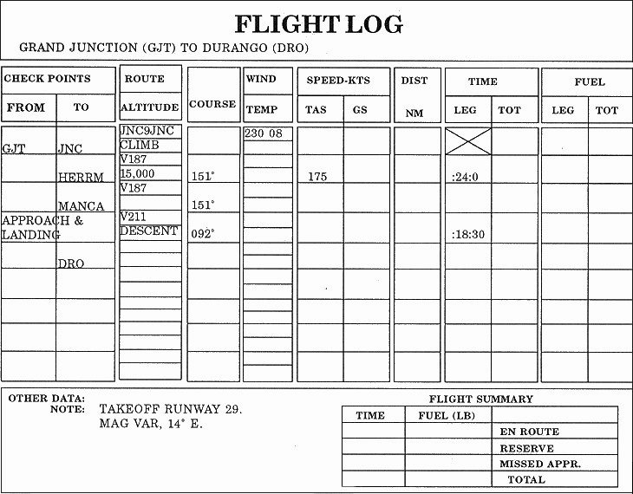

Figure 22.

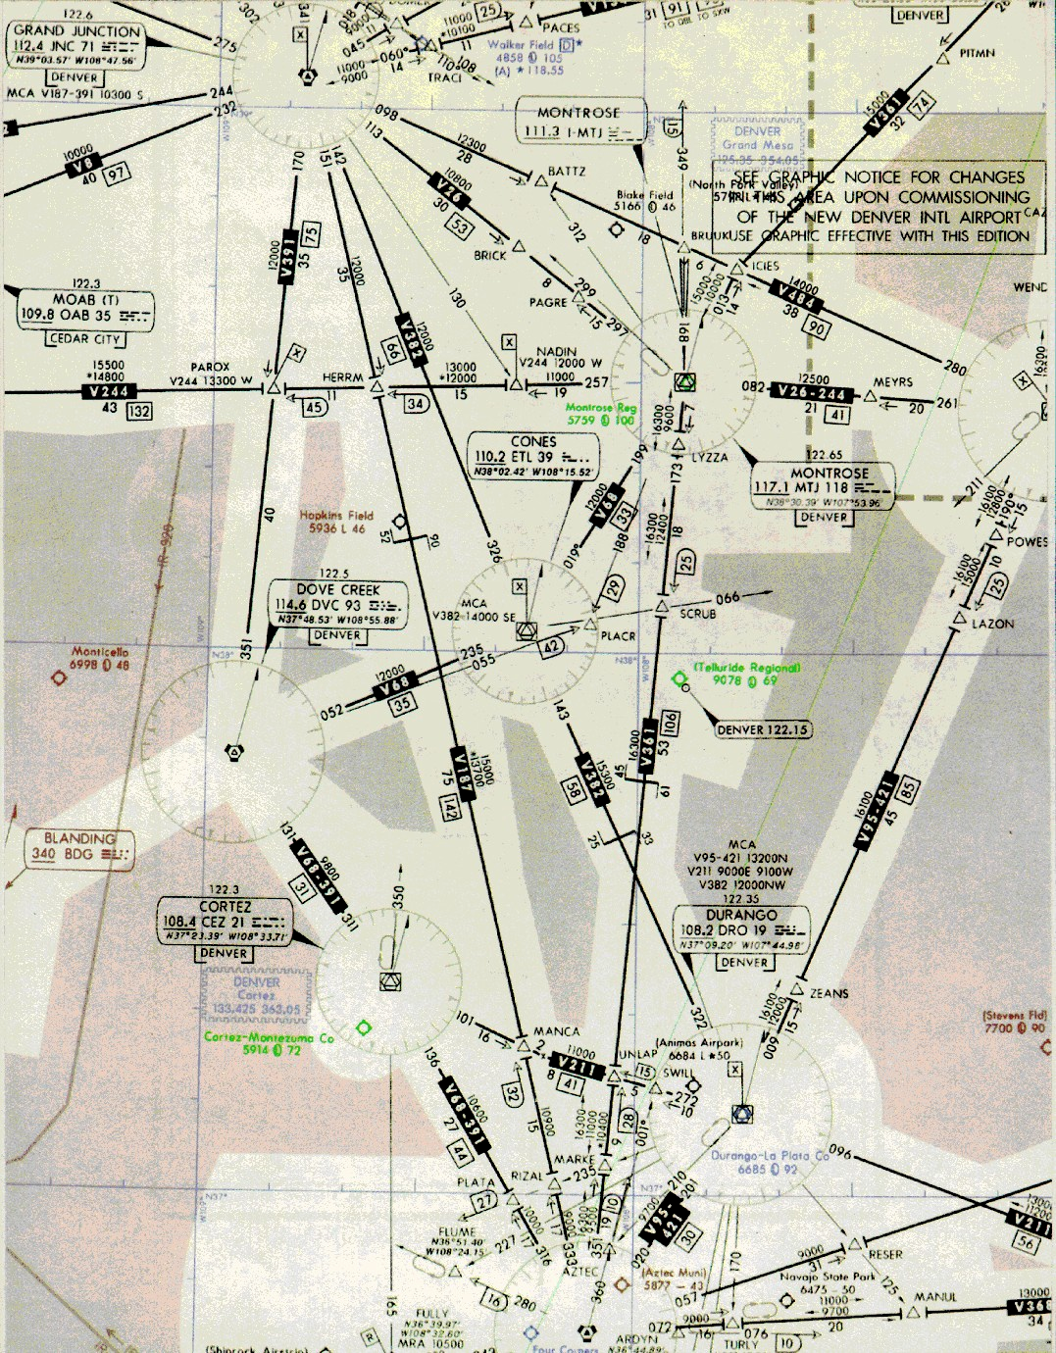

Figure 24
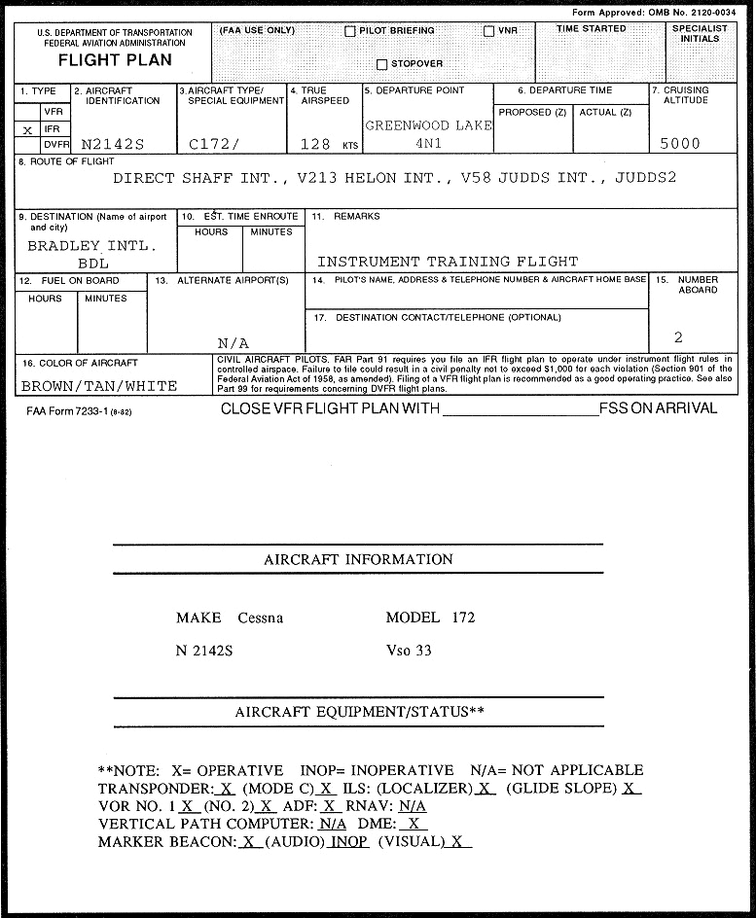

Figure 69

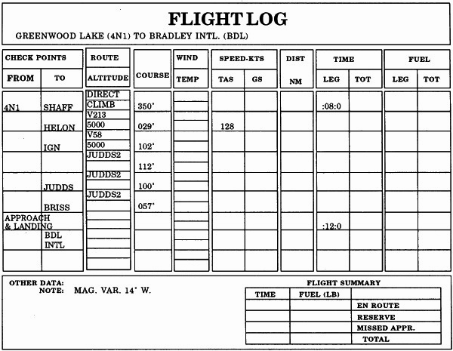

Figure 70

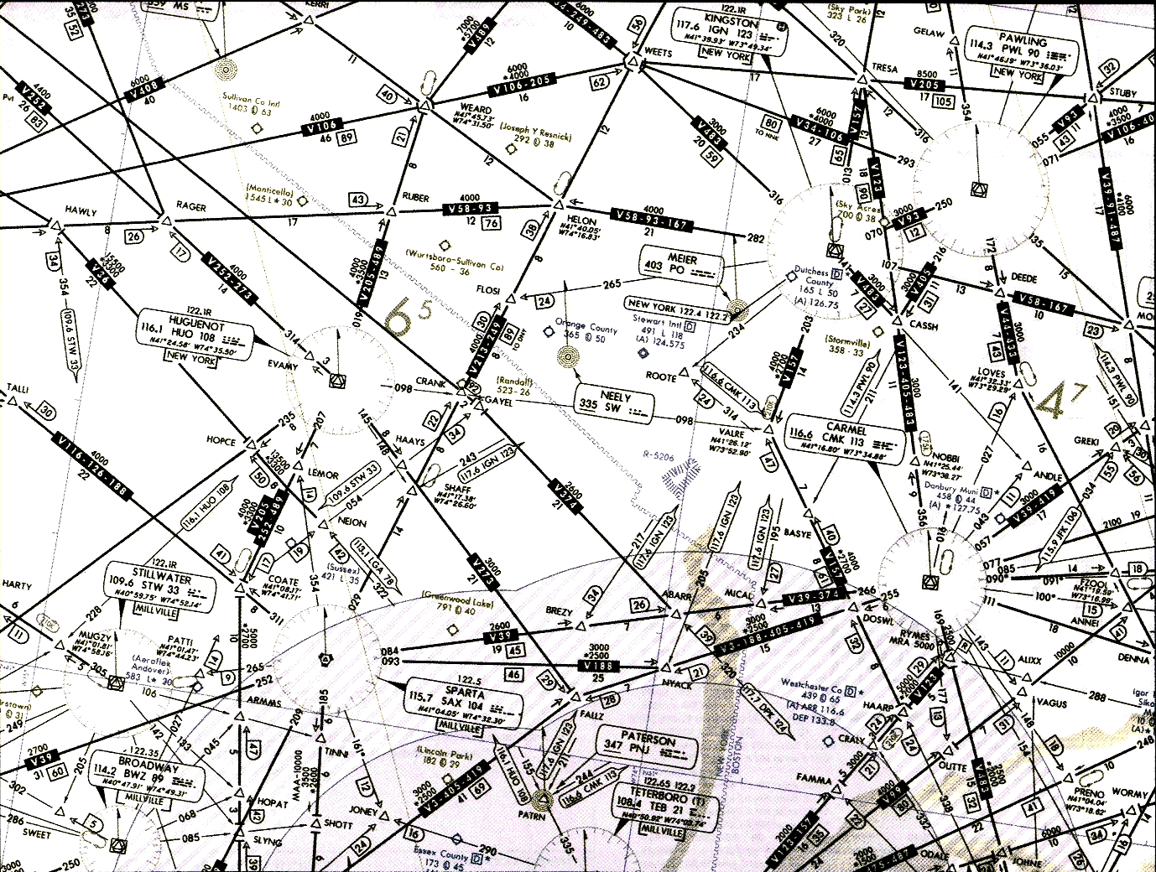

Figure 71
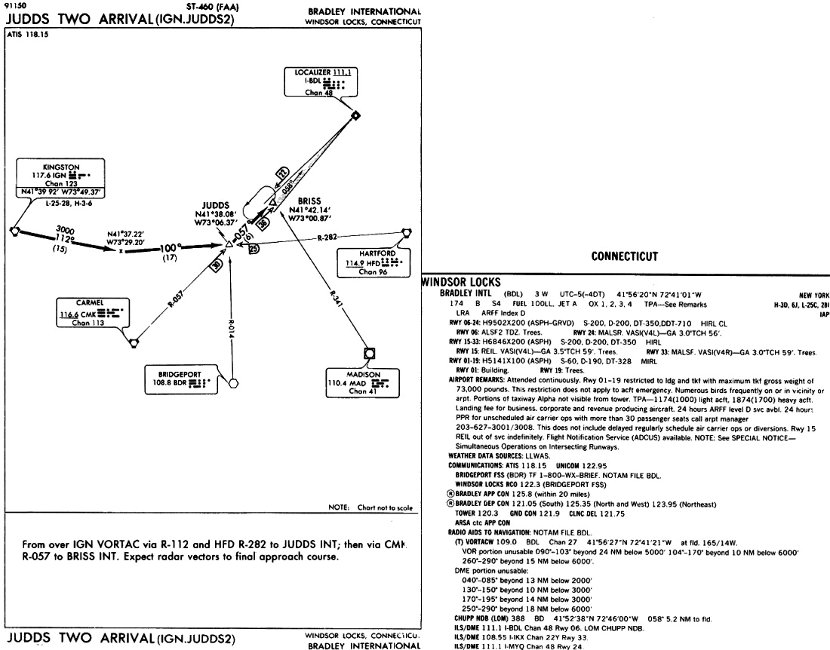

Figure 72
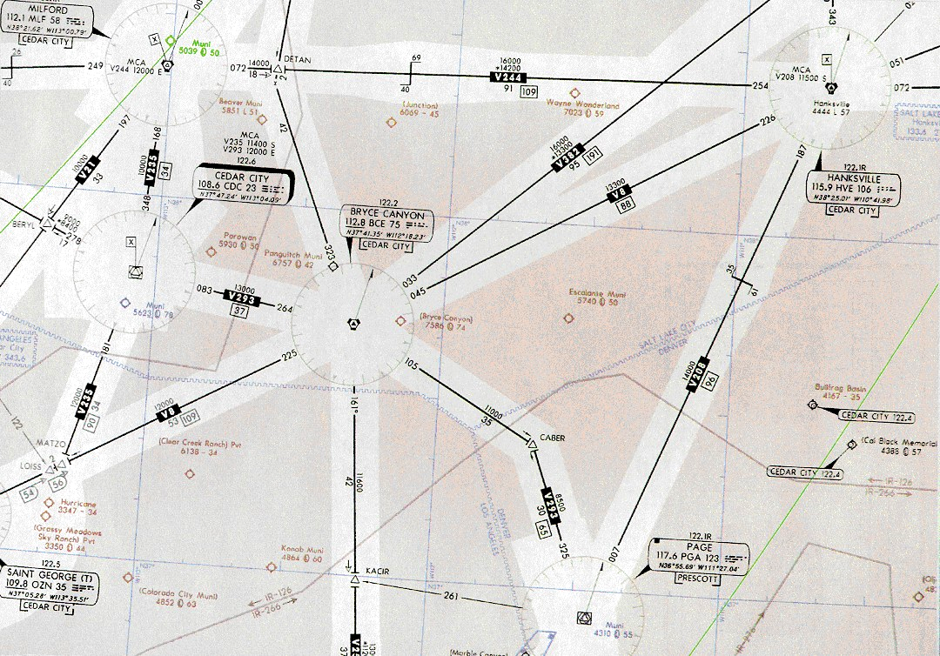

Figure 89
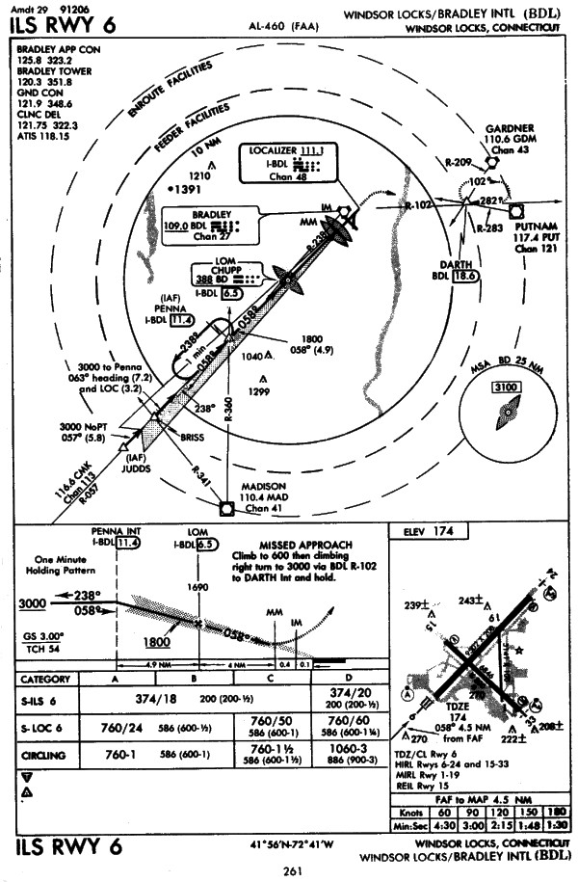

Figure 73

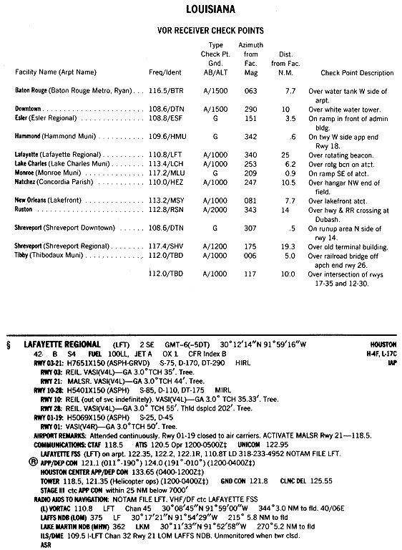

Figure 64

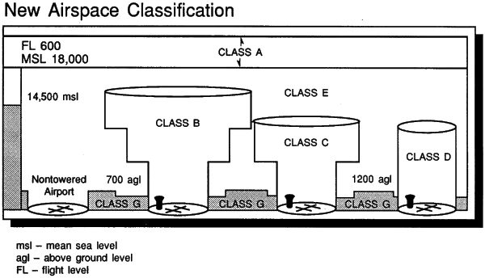

Figure 93
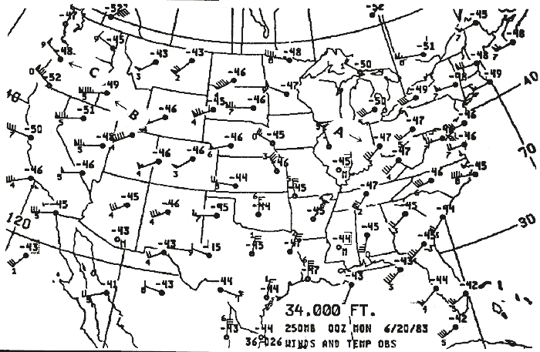

Figure 12

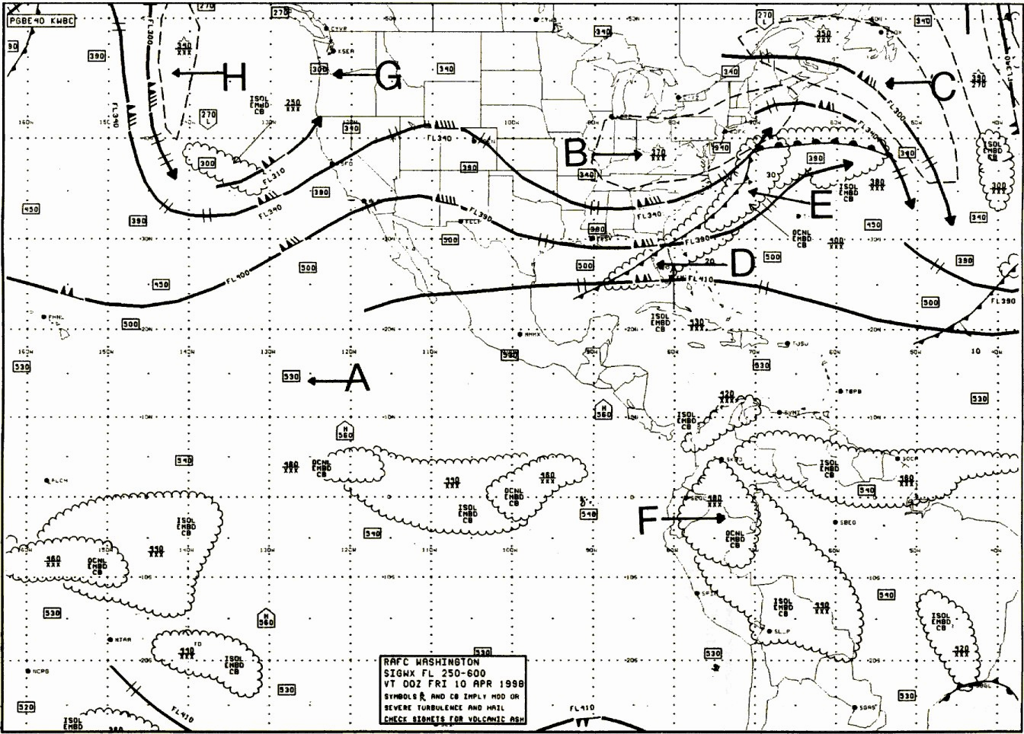

Figure 7

